Synopsis

This web system is to attend Ger’s mechanical garage needs. It is a small garage which carries out check-ups and fixes on cars, motorbikes, small vans and small buses.

Ger manages a small team with 4 staffs. Those staffs are able to maintain different type of vehicles. The staff responsible for maintenance check, in some cases it will require parts or supplies (e.g. fluids, oil, tyres) which the staff must find in the stock.

Due to it, this system will provide to the customers book vehicles in for check-up or service.

Computing General Areas

Aiming to build it, I’ll use Java 8, MySQL, JPA, Spring and angular to cover all the garage web system areas.

* Java: Using it on this project is important because it’s an object oriented language widely spread and there are many professionals, forums and guides available.
* MySQL: It’s a robust database which can process a huge amount of data and at the same time this DB is open source.
* JPA: By using this API is possible map the database using annotations what makes coding easier as it isn’t necessary create all queries for the DB.
* Spring: This framework is used to build micro services which can be accessed by other system even if they are not coding with Java because spring uses JSON mostly.

Proposed Plan

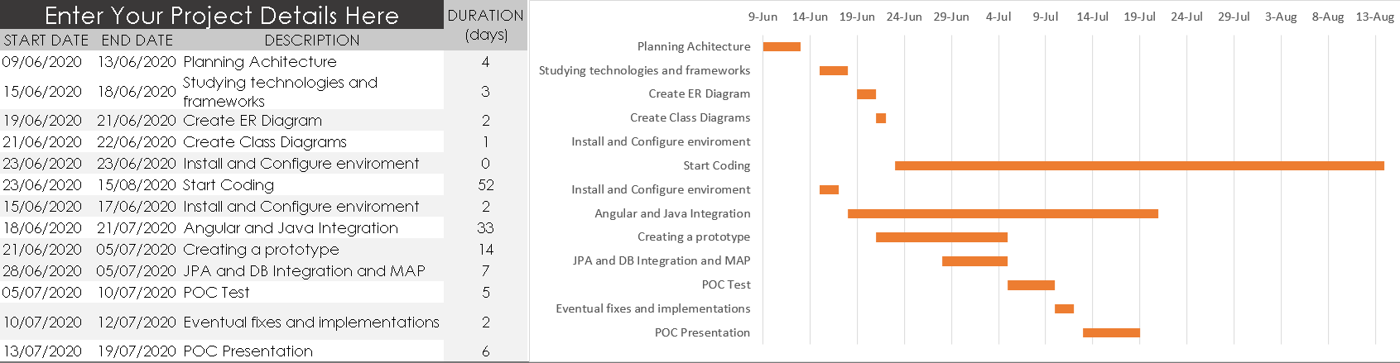

Project Reasons

This application will be used for Ger, his customer and staffs.

A customer can access the application and register himself and his vehicle. After ha makes an appointment for check-up or service. In the booking can be chose the following: 1) Annual Service, 2) Major Service, 3) Repair/Fault and 4) Major Repair.

Also, will be a login module where all the stakeholders can be registered. The customer after logging in can book a service which will be attached to a staff. The staff in charge of the service must finish the appointment describing the service and which supplies or car parts have been used for it.

Use Case

In a real world this application can be used at any small or big garage business. This web system has been built to attend Ger’s garage but it’s been developed in a generic way aiming to attend as much business as possible. For the most of the small companies, they can simply reuse it and for others small or big companies some changes and modules need to be made.